The Budget Fashionista Unique: 87,488 Diamond Ideals

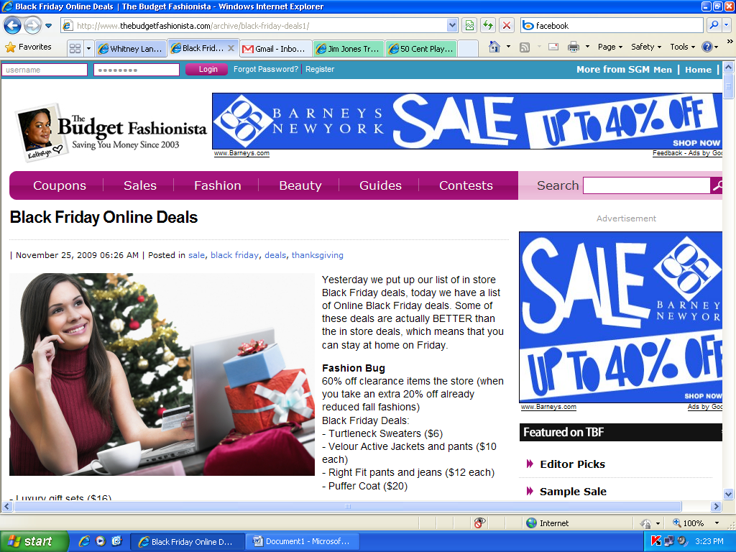
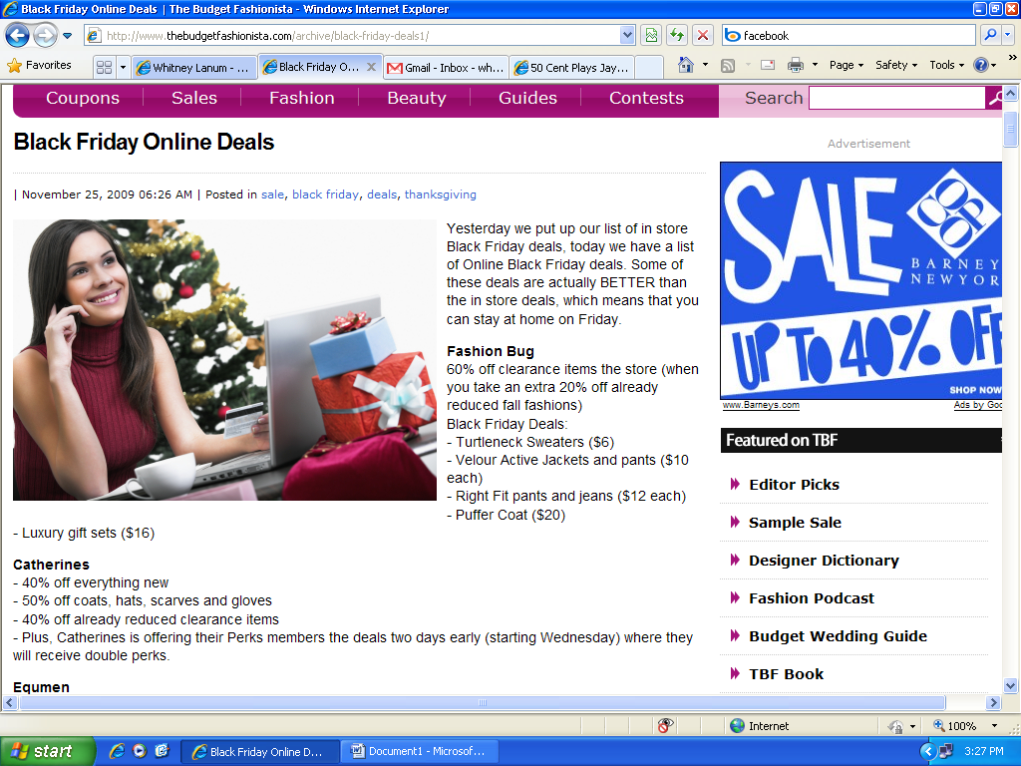
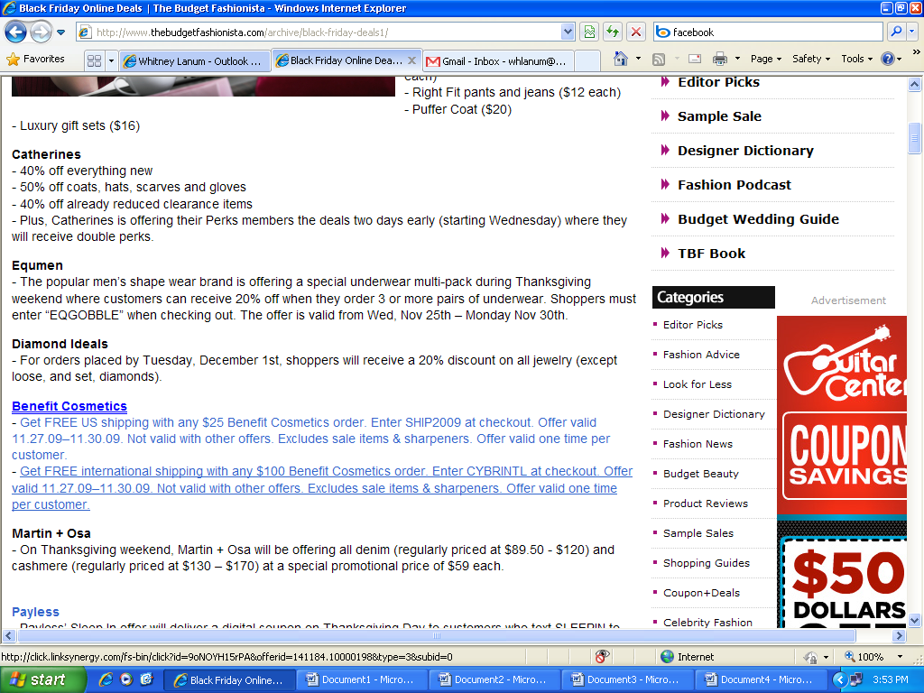

http://www.thebudgetfashionista.com/archive/black-friday-deals1/

