Elle Unique: 901,423 Diamond Ideals

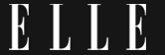
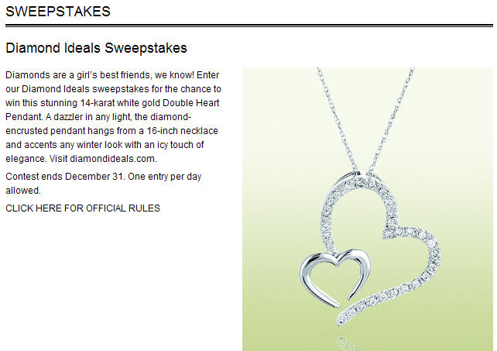

http://www.elle.com/Sweepstakes/Diamond-Ideals-Sweepstakes

